Naaman Healed of Leprosy
2 Kings 5

“I Love Jesus” visor
You can’t put a price tag on God’s blessings. There is NOTHING in this world that compares to the spiritual blessings that God has prepared for those who love Him
(1 Corinthians 2:9).

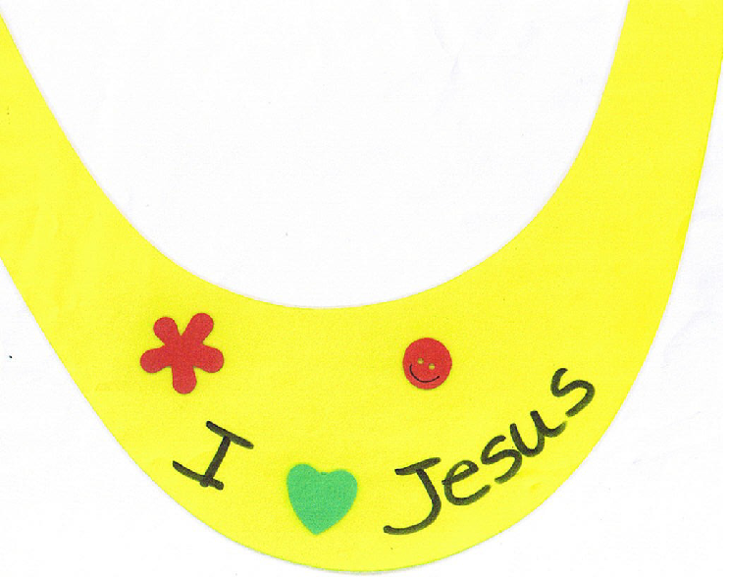

Directions:
- Print “I Love Jesus” on Foam Visor Hat, www.discountschoolsupply.com, 8WWFMVHAT,
with a permanent marker.
- Decorate visor with foam stickers and permanent markers.
- Apply Key Verse to finished craft.

Naaman Healed of Leprosy
2 Kings 5

“Healed by Faith” Bracelet

You can’t put a price tag on God’s blessings. There is NOTHING in this world that compares to the spiritual blessings that God has prepared for those who love Him
(1 Corinthians 2:9).

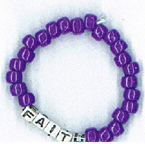

Directions:
- Choose a Faith beaded bracelet, www.guildcraftinc.com, #401-038
- Put together bracelet according to enclosed directions.
- Try on your bracelet and share with others how God has blessed you through your faith in Him!

